# Autonomous Vehicle Cybersecurity Manufacturer Disclosure Statement

# Revision

Version 2

1/5/22 10:35 AM

# Author

Charles Wilson

# Abstract

This document details the process to be used to identify the cybersecurity practices currently used by a supplier.

# Group / Owner

Security / Systems Security Analyst

# Motivation

This document is motivated by the need to have adequate understanding of supplier cybersecurity practices prior to selection for the development of security-related elements to be used in products subject to compliance with standards such as **ISO 21434** and **ISO 26262**.

# License

This work was created by **Motional** and is licensed under the **Creative Commons Attribution-Share Alike (CC4-SA)** License.

[**https://creativecommons.org/licenses/by/4.0/legalcode**](https://creativecommons.org/licenses/by/4.0/legalcode)

# Overview

The **Autonomous Vehicle Cybersecurity Manufacturer Disclosure Statement** is intended to establish supplier practices in the following areas:

* Documentation
* PII management
* Audit controls
* Access controls
* Product upgrading
* Data backup
* Disaster recovery
* Data integrity / confidentiality
* Malware handling
* Device lifecycle management
* Software bill-of-materials
* Hardening
* Connectivity / remote access

The following diagram illustrates the process to be used:

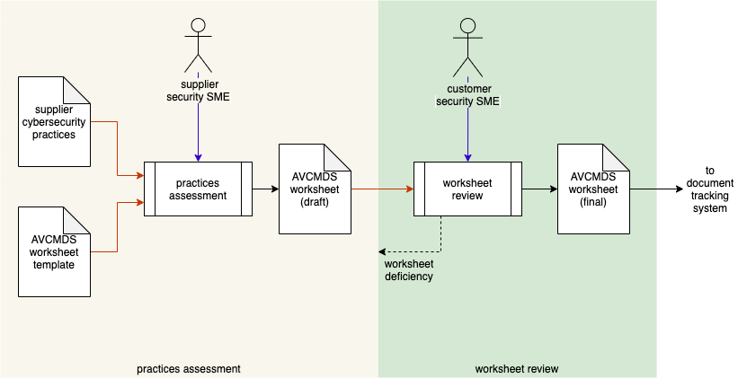

# Process

## Practices Assessment

|  |  |
| --- | --- |
| **Inputs** | Supplier cybersecurity practices  AVCMDS worksheet template |
| **Outputs** | AVCMDS worksheet (draft) |
| **Participants** | Supplier Security SME |

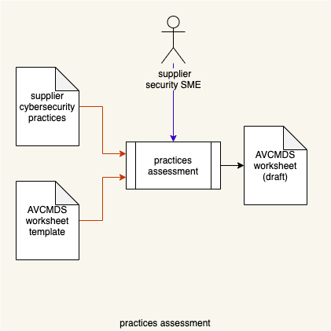

Using the **AVCMDS (Autonomous Vehicle Cybersecurity Manufacturer Disclosure Statement)** **worksheet template** **[5],** the supplier security SME creates an **AVCMDS worksheet (draft)**, based on an understanding of the existing **supplier cybersecurity practices**.

## Worksheet Review

|  |  |
| --- | --- |
| **Inputs** | AVCMDS worksheet (draft) |
| **Outputs** | AVCMDS worksheet (final) |
| **Participants** | Customer Security SME |

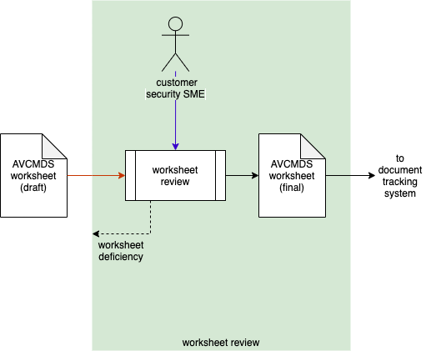

The customer security SME reviews the **AVCMDS worksheet (draft)**. If any deficiencies are identified, a **worksheet deficiency** is reported to the supplier for resolution. If no deficiencies are identified, the **AVCMDS worksheet (final)** is entered into the document tracking system for future reference.

**Note:** Information in the **AVCMDS worksheet** will be used in the creation of the **Cybersecurity Interface Agreement** **[6]**.

# References

1. **Safety data sheet**  
   [**https://en.wikipedia.org/wiki/Safety_data_sheet**](https://en.wikipedia.org/wiki/Safety_data_sheet)
2. **Hazard Communication Standard: Safety Data Sheets**  
   [**https://www.osha.gov/sites/default/files/publications/OSHA3514.pdf**](https://www.osha.gov/sites/default/files/publications/OSHA3514.pdf)
3. **Development of Material Safety Data Sheets**  
   [**https://jrm.phys.ksu.edu/Safety/kaplan.html**](https://jrm.phys.ksu.edu/Safety/kaplan.html)
4. **Manufacturer Disclosure Statement for Medical Device Security**  
   [**https://www.nema.org/standards/view/manufacturer-disclosure-statement-for-medical-device-security**](https://www.nema.org/standards/view/manufacturer-disclosure-statement-for-medical-device-security)
5. **AVCMDS Worksheet template.xlsx (AVCDL template document)**
6. **Cybersecurity Interface Agreement (AVCDL secondary document)**